

NAME: DANISH BALAJI B 192512122

Exp No: 2 GENERATION OF SQUARE WAVE USING PROTEUS
AIM: To write an assembly language program to Generate square wave using AT89C51.

PROGRAM CODE:
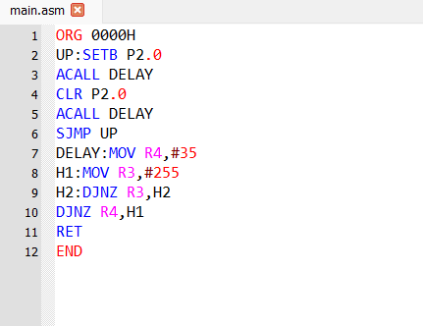

OUTPUT:
